Slot d OS LAB WORK
EXP 1:
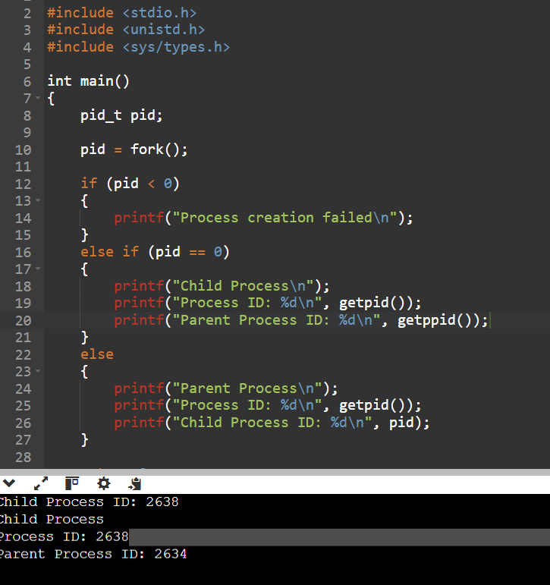

Exp no 2 :

